# **Efficient Container Placement System (ECPS) : AI Based solution**

# **Overview:**

A Yard Management System (YMS) is a software solution which INTECH has developed and is used in logistics and supply chain management to efficiently manage the movement and storage of goods within a yard or facility. A yard typically refers to an area within a distribution centre, manufacturing plant, or transportation hub where containers, trailers, and other assets are stored temporarily before being loaded, unloaded, or transferred.

Containers are standardised units used for transporting goods, often made of metal or other materials, designed to be easily handled by various modes of transportation, such as ships, trucks, and trains. These containers can vary in size (typically 20ft and 40 ft) and type, such as refrigerated container or reefer container, which is a specialised type of shipping container designed to transport goods that require temperature-controlled environments such as vegetables, fruits, dairy products etc.

A YMS helps organisations to streamline operations by providing real-time visibility into yard activities, tracking the location of containers and trailers, optimising the movement of assets, and coordinating tasks such as loading, unloading, and transshipment. This enhances efficiency, reduces delays, and minimises congestion in the yard, ultimately improving the overall supply chain process.

The demand for artificial intelligence (AI) solutions in corporate settings has arisen from several pivotal factors. A client in the field of container management, for instance, aims to create an AI-driven Yard Management System (YMS). This system intends to provide container location recommendations to minimise unnecessary movements during unloading, ensuring containers are placed in proximity to their destinations.

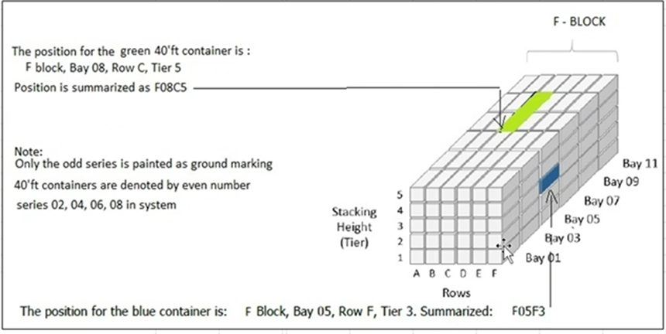

PS: Ignore the ‘Note’ about the 40ft containers in the picture.

The Hierarchy Order

* Yard
* Block (Area)
* Row / Bay
* Level (Tier)

Solution should provide container placement in nearby locations with each other as well as the shuffling must be reduced while taking out those containers. This not only improves efficiency, but it also frees up employees to focus on higher-value tasks that require human skills and expertise.

Intech having their own AI team which will be responsible for creating efficient systems using state of the art methods and algorithms. Still it would be great if the solution is provided by students having larger access to research content.

The simple way of organising containers is a rule based system, which will put containers as it finds the empty spaces. There are not many constraints used and no optimization is done in this rule base system. Your proposed system must save time and fuel for arranging containers and offer less shuffling. The proposed system should be more capable to integrate custom rules and regulations which come in the future.

Eg. User case 1 : Let's say 10 containers come to the yard by rail or by road, then we need to assess the containers present in the yard and the containers which are coming to the yard.

1. **Predict the outgoing days of incoming containers based on past data given.**
2. **Identifying the right and optimised places in the yard.**
3. **Assign the containers in that location.**

In order to reduce this overhead, we are looking for a smart solution where we have an optimization based solution. Avoid using a rule based system.

# **Problem Statement**

The goal of this project is to develop an AI-powered system which will guide and place the incoming containers in an optimised way such that there will be less shuffling and the best way to place containers. Container placement must be done within a short time span. The system should be able to provide relevant and accurate location with containers.

Proposed solution must consider following things

* Containers must be segregated by their size like 20ft and 40ft.
  + In a given row and bay all levels must be of the same container size.
* Locations are specific for Import, Export and for Empty containers. System must identify the places and put those containers there.
* All possible locations must be taken in such a way that less shuffling must occur while taking out containers.
* If anyhow the system assigns the location which is at the higher level but lower levels are empty, the location must get updated. In short no location must be suggested which is in the air.

The following information will be provided:

1. Gate in and Gate out time of the containers.
2. Containers of data which are coming to the yard.
3. Current locations which are empty or filled in the yard.

ECPS System Responsibility:

* **Predict the timing of the individual containers:** The system must be able to predict the leave time of the containers.
* **Generate the optimised location of an individual container:** Based on leave time our system must place the containers in an optimised way such that it leads to less shuffling while carrying out outgoing operation.
* **Scale to handle large volumes of containers:** The system should be able to handle large volumes of containers without compromising on performance or quality of responses.
* **Data privacy and security:** It should collect necessary data only, obtain the consent wherever required, Protect the data while in transit and stored, remove personal identifiers, and dispose of the data properly.
* **Ethical use of AI:** Ensure that whatever is developed and used in an ethical manner.

# **Must Have**

* Design AI based intelligent algorithms which can fulfil above requirements.
* Present solution in PPT
* **Necessary supporting Documentation:** User manuals or technical specifications that may help judges understand project submission.
* **Demo video:** Good to have, if a short video (2-5 minutes) that showcases the project and its features. This should demonstrate how the project works and how it solves the problem.

# 

# **Evaluation Criteria**

* Quality and effectiveness of solution
* Potential for real-world impact